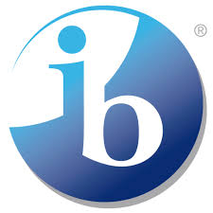

**International Baccalaureate Mission Statement**

The International Baccalaureate® aims to develop inquiring, knowledgeable and caring young people who help to create a better and more peaceful world through intercultural understanding and respect.

To this end the organization works with schools, governments and international organizations to develop challenging programmes of international education and rigorous assessment.

These programmes encourage students across the world to become active, compassionate and lifelong learners who understand that other people, with their differences, can also be right.



**Mission Statement**

Miles Elementary will provide a safe and nurturing environment that promotes academic success, models

life-long learning and prepares learners to become active globally compassionate and open-minded citizens.